Up the River

**Race to the Harbor**

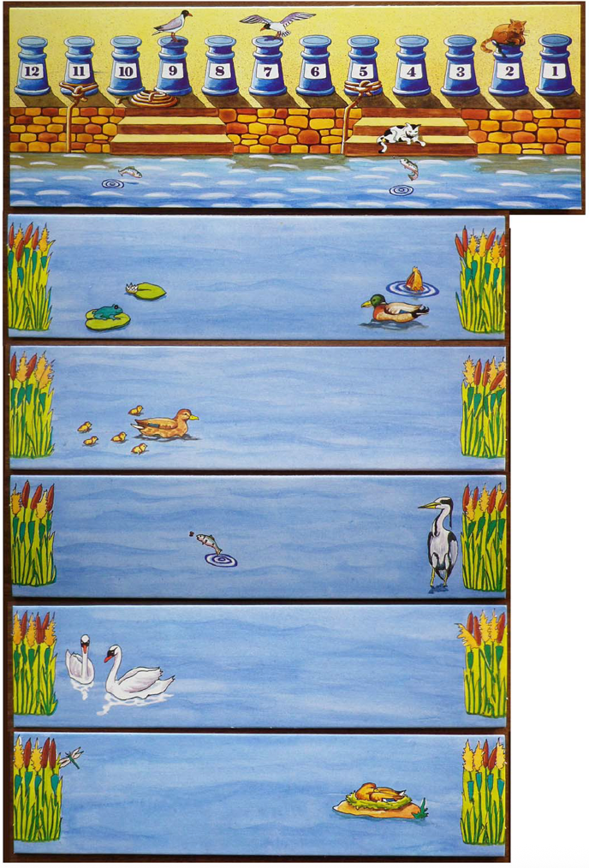

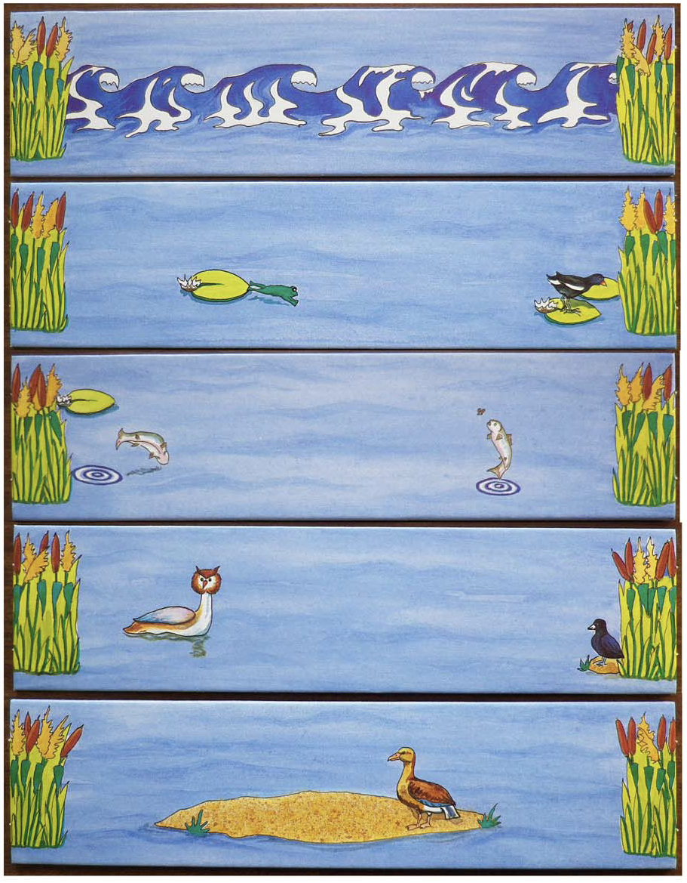

**Up the River - Race to the Harbor**

**Age:** 6 to adult

**Players:** 2-4

**Author:** Manfred Ludwig   
**Illustration**: Michael Wollert

**Contents:**

* 1 Harbor (goal) card
* 8 River cards
* 1 Sandbank Card
* 1 High Tide Card
* 12 Wooden sailboats
* 1 Six-Sided Die
* 1 Set of Game rules

**Description:**

Quickly sail your boats up the river, because the current can change and sweep you over the waterfall and out of the game! Once you make it to the harbor try for the best places to tie up your fleet.

# Object of the game

Each player tries to get all three of their boats into the harbor and to earn the most points for each boat.

# Game preparation

Place the harbor card (goal) and the 10 River cards on the table, following the exact order shown at the start of this file.

Each player chooses a color and takes all three boats of that color. *All players' boats begin the game on the fourth river card from the bottom.*

# Game rules

The youngest player goes first. Play proceeds in a clockwise direction.

On your turn, roll the die and sail one of your boats toward the harbor for as many river cards as the number thrown.

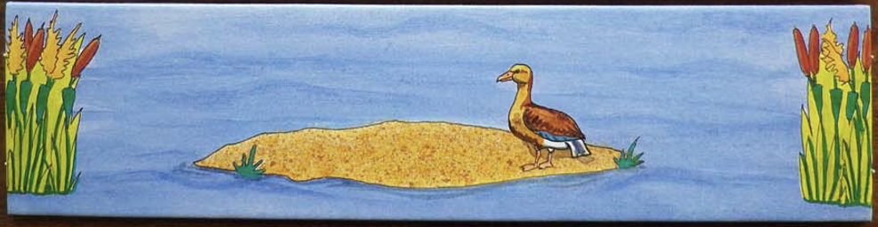

# Sandbank card

Every boat runs aground on the sandbank. Even though the number you roll might otherwise let you sail on, your turn ends here. On your next turn you may roll again and move on.

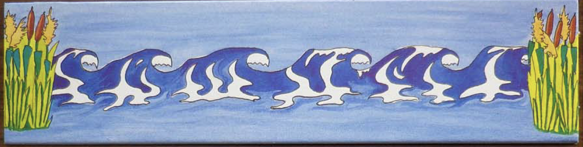

# High Tide card

If you land on the card with waves on a direct throw, this means the tide is in your favor and you may advance three more spaces or cards.

**Rolling a 6 on the die gives you another choice.**A six can either mean a good wind for your fleet or an ill one for your opponents. You have two choices:

**Option 1 – A Good Wind.**If you roll a six, you may move any one of your boats up to join the next one of your boats farther up the river. (Your third boat in play may move to the same river card as the second; or the second may move to the same river card as the first) If the sandbank is in the way, however, you must stop there. If you have only one boat left on the river, or if all three boats are already on the same card, you may not use this option.

**Option 2 – An Ill Wind.**If you roll an arrow and cannot or do not choose the Good Wind Option, you may take one of your opponents' boats and move it back to the nearest boat of the same color. It does not have to stop at the sandbank. If there is only one boat of a given color on the river, or if all three of one color are on the same river card, you may not use this option.

If you cannot use either the Good or the Ill Wind, you lose your turn.

# The Waterfall

Now comes the exciting part! Each player rolls the die and moves one of his or her boats. When it's the first player's turn again, the tide changes.

If you are the first player, each time it is your turn, take the bottom (farthest from the harbor) river card and move it to the top (closest to the harbor). If there are any boats on the bottom card, they fall over the waterfall and are out of the game.

If you lose all your boats over the waterfall, you are out of the game. Better luck next time!

# To enter the harbor

You do not need a direct throw to reach the harbor (if, for example, you are 2 spaces away and roll a 3 you may enter).

Once you reach the harbor, you will want to tie up your boat at the dock with the highest number (point value). *For example, the first boat to enter the harbor will always dock at number 12, the second at 11, and so forth. There can be only one boat at each dock.*

# End of the game

The game is over when all boats have either gone over the waterfall or reached the harbor. Each player adds up the numbers on his or her docks, and the player with the highest score wins.

